WEEK 5

1.
import java.util.Scanner;

public class longsuffix{
public static void main(String[] args) {
Scanner scanner = new Scanner(System.in);

int n = scanner.nextInt();
scanner.nextLine();

String[] strs = new String[n];
for (int i = 0; i < n; i++) {
strs[i] = scanner.nextLine();
}

String suffix = longestCommonSuffix(strs);

System.out.println(suffix.isEmpty() ? "No common suffix" : suffix);
}

public static String longestCommonSuffix(String[] strs) {
String suffix = strs[0];

for (int i = 1; i < strs.length; i++) {
suffix = findCommonSuffix(suffix, strs[i]);
if (suffix.isEmpty()) {
return "";
}
}

return suffix;
}

public static String findCommonSuffix(String s1, String s2) {
int len1 = s1.length();
int len2 = s2.length();
int i = len1 - 1;
int j = len2 - 1;
String result = "";

while (i >= 0 && j >= 0 && s1.charAt(i) == s2.charAt(j)) {
result = s1.charAt(i) + result;
i--;
j--;
}

return result;
}
}
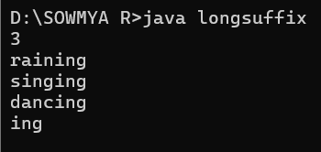

2.
import java.util.*;
class string {
public static void main(String[] args) {
Scanner scan = new Scanner(System.in);
String sentence = scan.nextLine();
String[] words = sentence.split(" ");
for (String word : words) {
if (word.length() % 2 == 0) {
System.out.println(word);
}
}
}
}
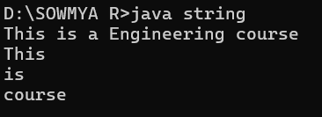

3.
import java.util.*;
class sb{
public static void main(String args[]){
StringBuffer s = new StringBuffer("Rajalakshmi ");
System.out.println(s);

s.append("College,Kanchipuram");
System.out.println(s);

s.insert(11," Engineering");
System.out.println(s);

int si = s.indexOf("Kanchipuram");

int ei = si+"Kanchipuram".length();

s.replace(si,ei,"Chennai");
si = s.indexOf("Chennai");
System.out.println(s);

ei = si+"Chennai".length();
s.delete(si,ei);
System.out.println(s);

s.reverse();
System.out.println(s);
}
}
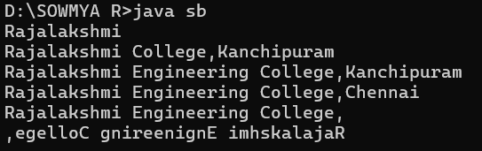

4.
import java.util.Scanner;

public class capital{
public static void main(String[] args) {
Scanner scan = new Scanner(System.in);
String s = scan.nextLine();
String[] words = s.split(" ");

for (int i = 0; i < words.length; i++) {
String word = words[i];
System.out.print(word.substring(0, 1).toUpperCase() + word.substring(1).toLowerCase() + " ");
}
}
}
